1. Code Design

<https://codedesign.ai/>

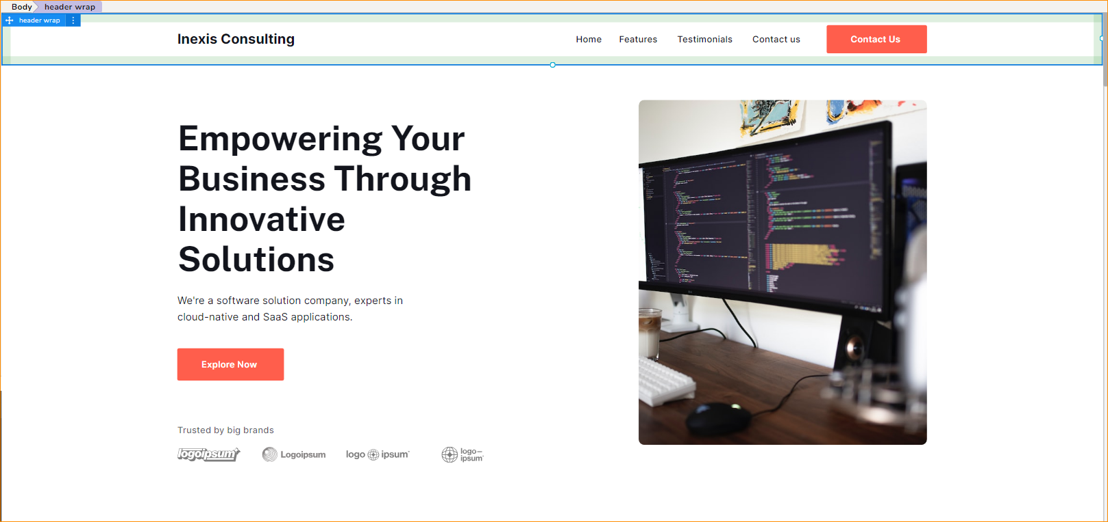

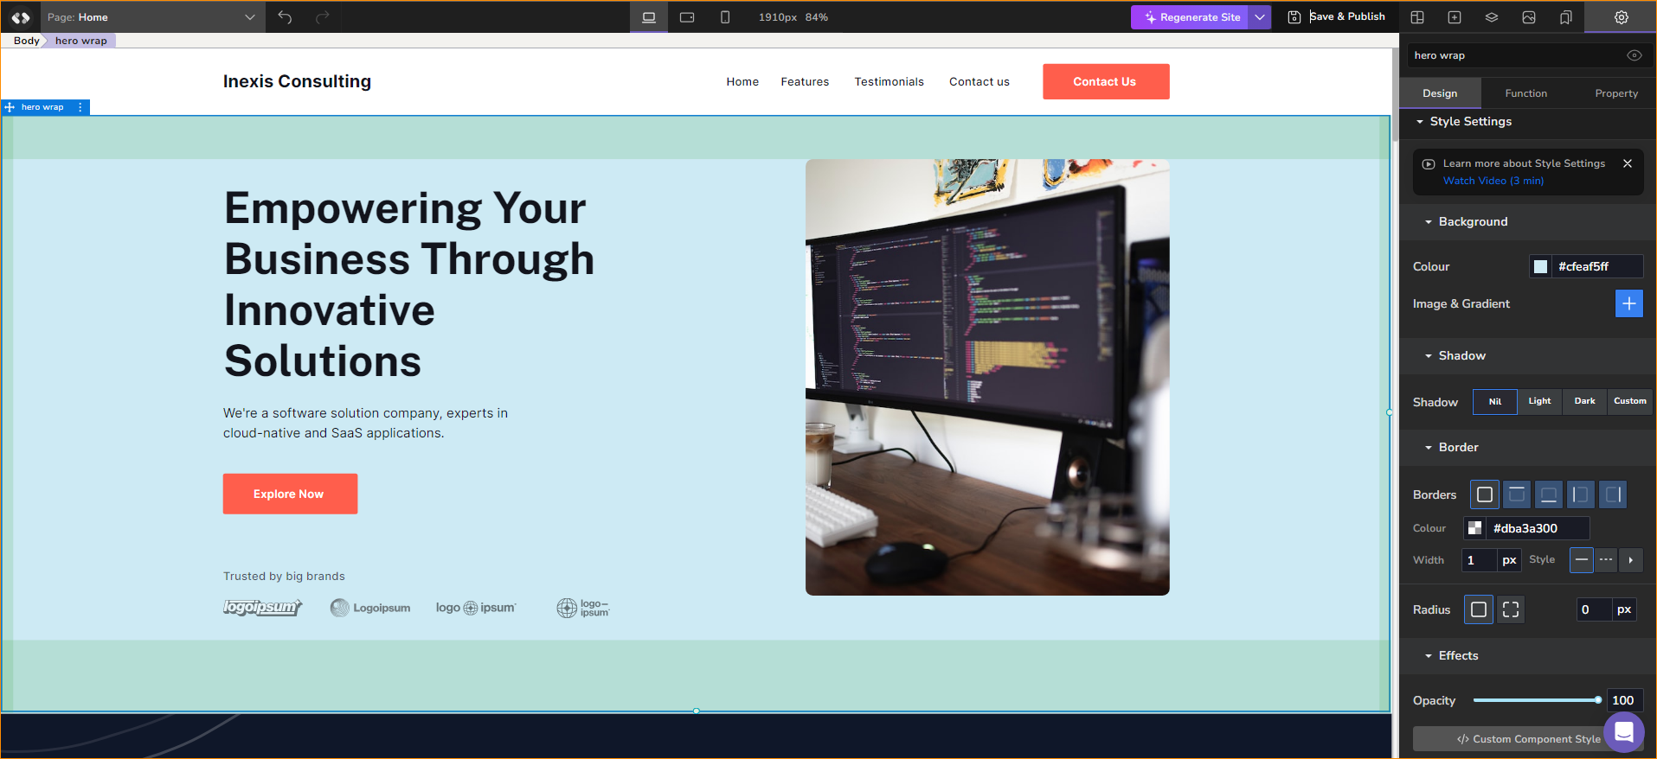

Pricing –

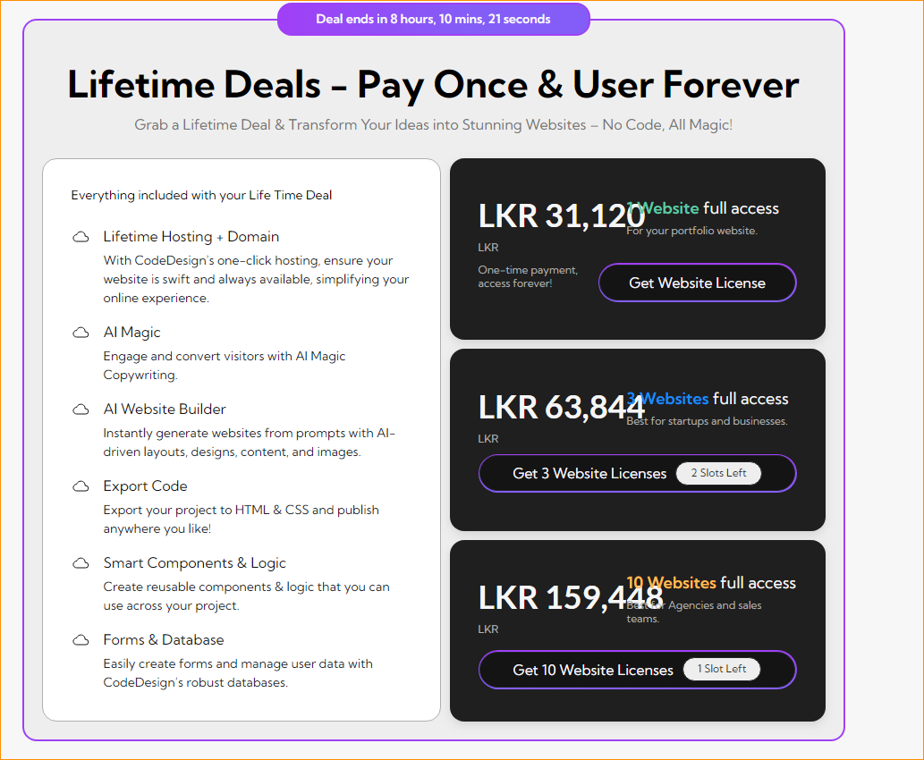

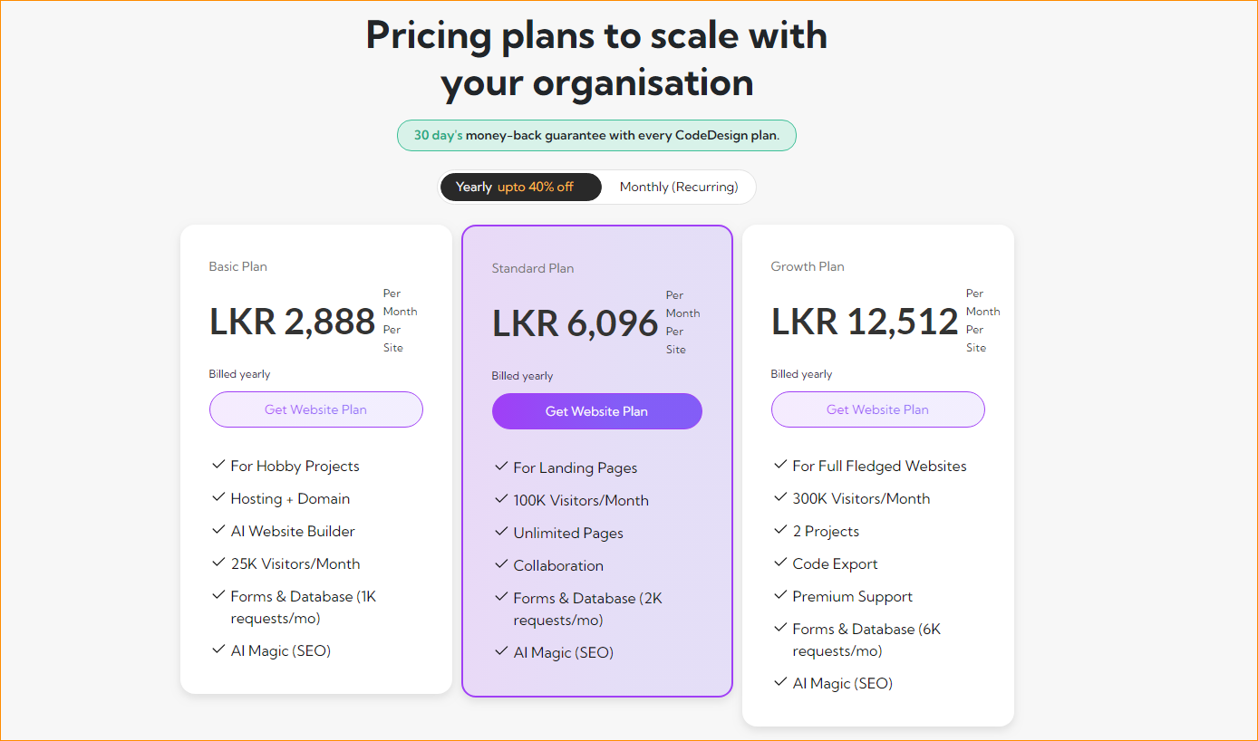

1. B12 web site builder

<https://www.b12.io/ai-website-builder/>

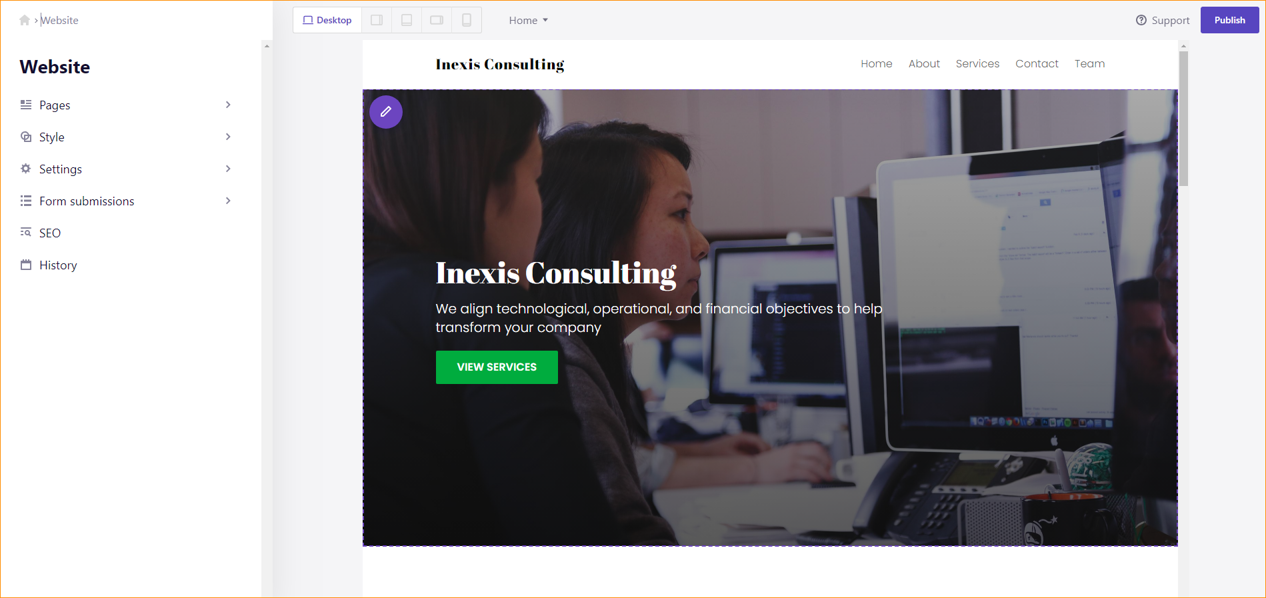

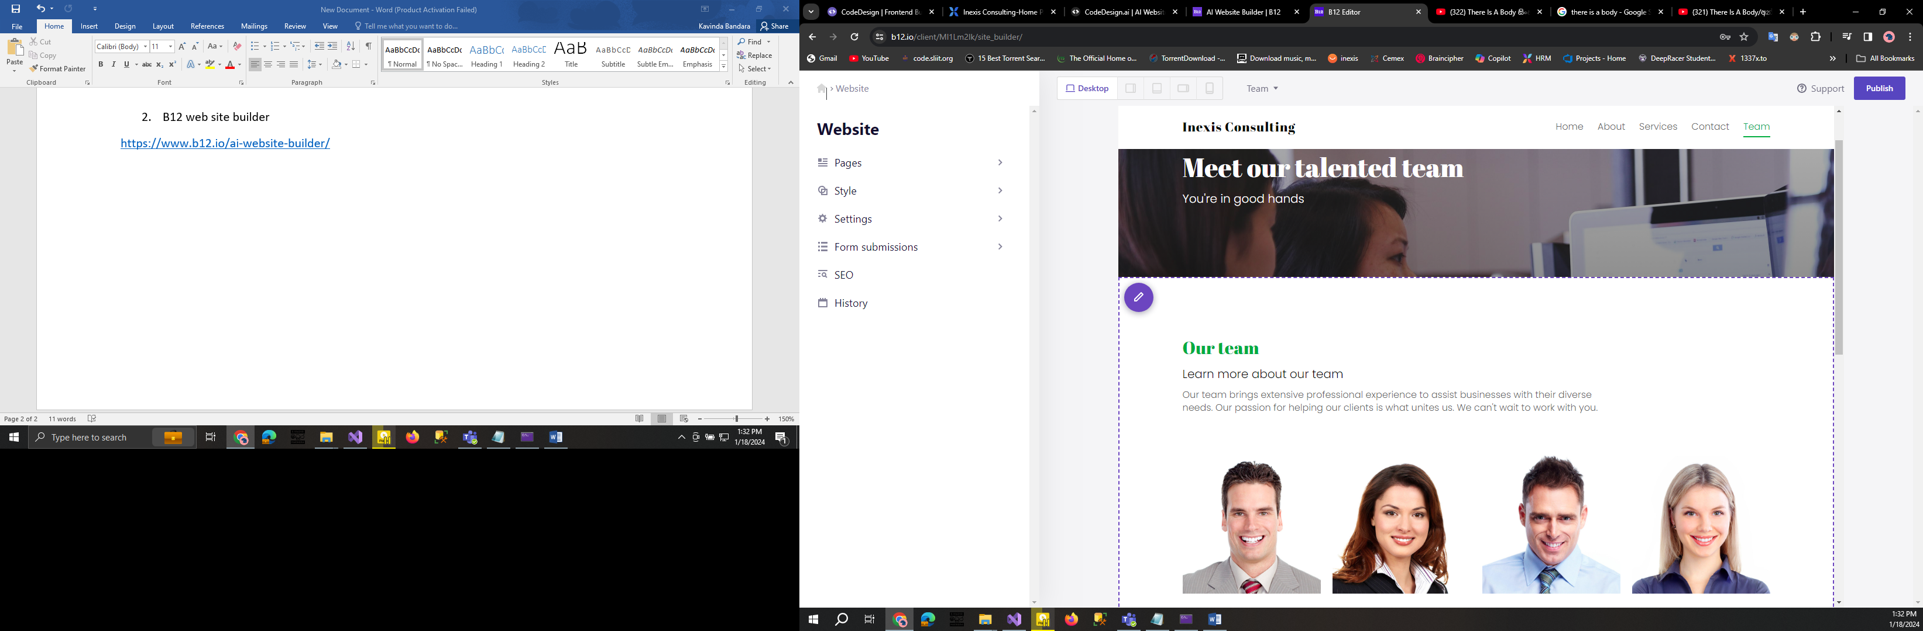

Pricing -

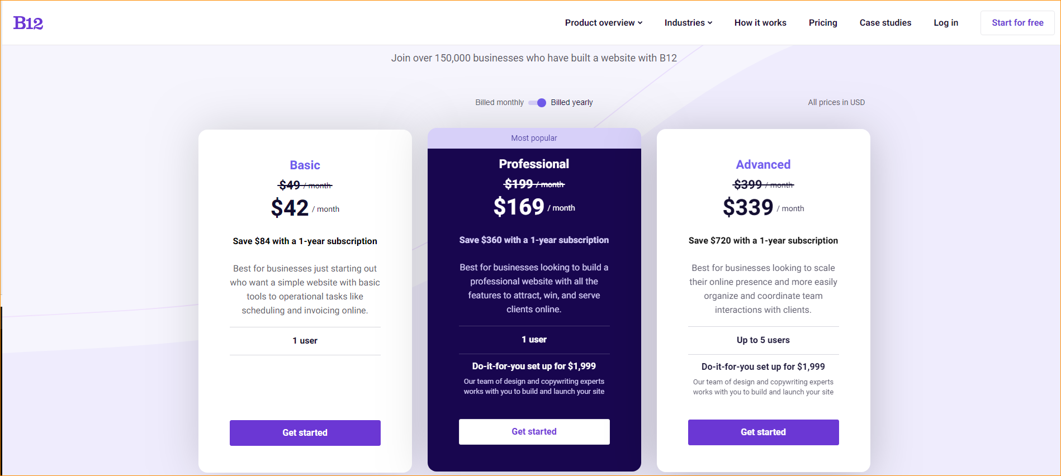

1. dorik

<https://dorik.com/ai-website-builder>

Coming soon.!

1. Boolipi

<https://bookipi.com/ai-website-builder/>

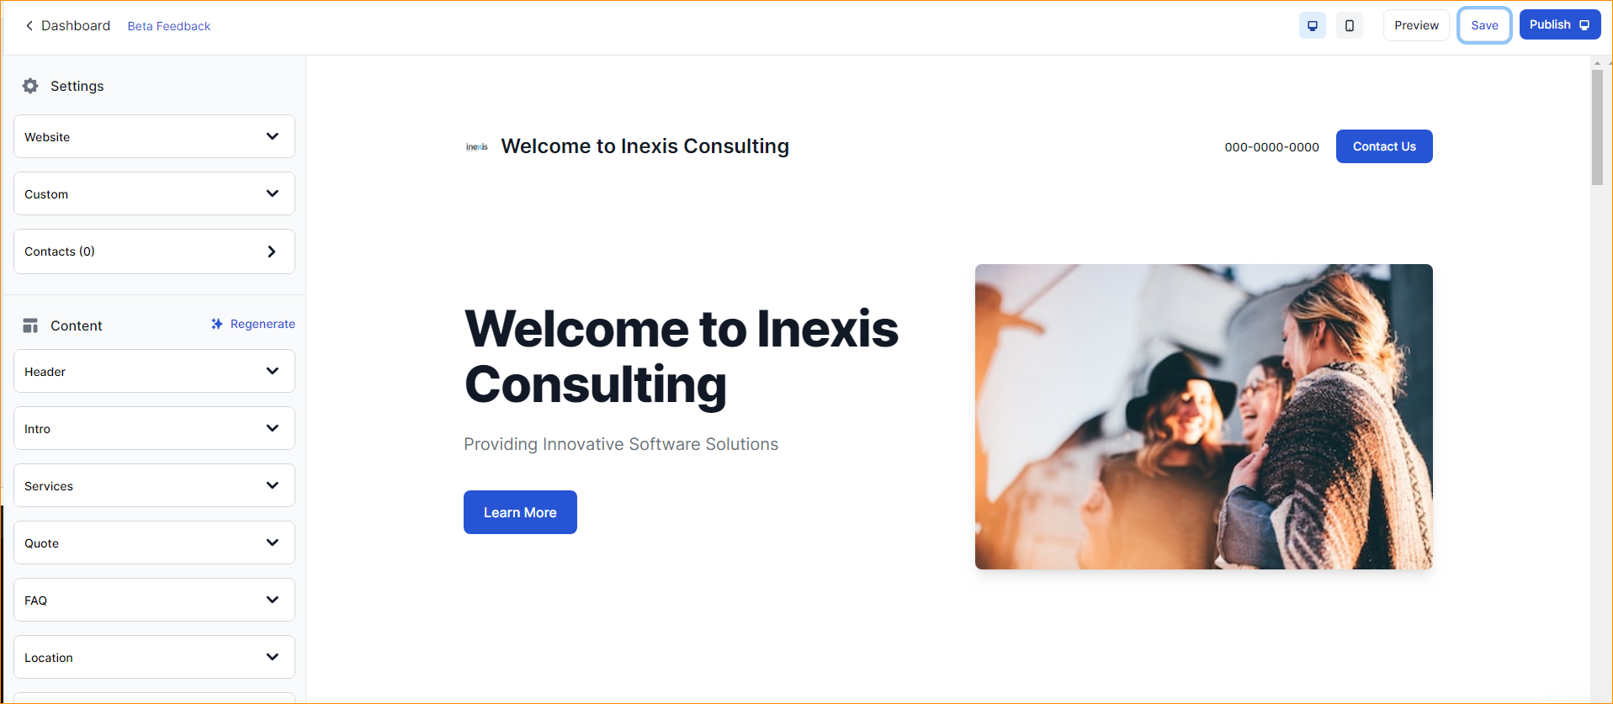

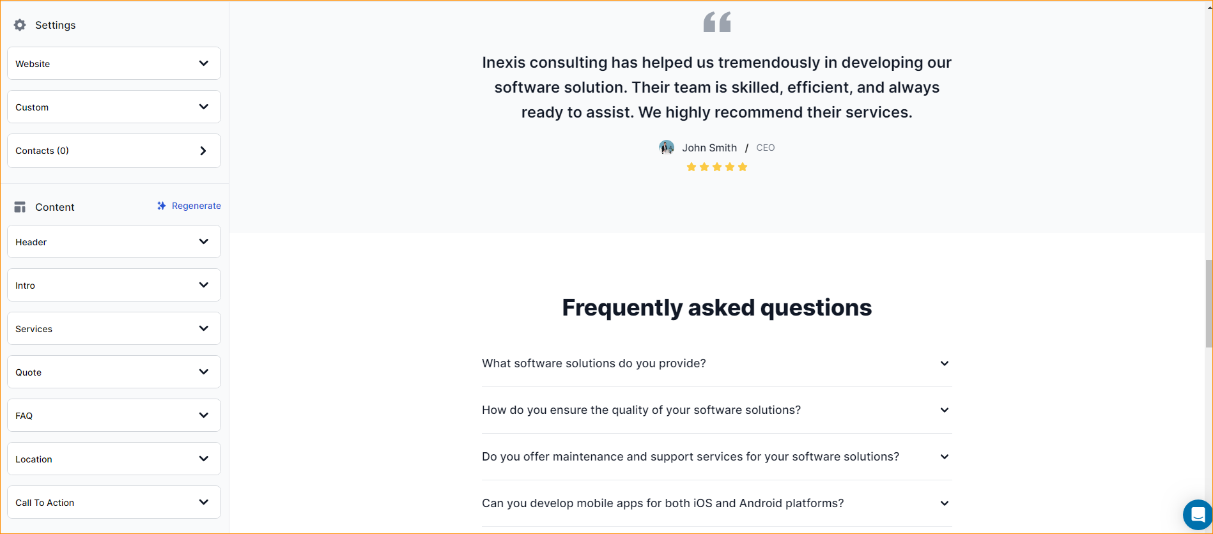

Pricing-

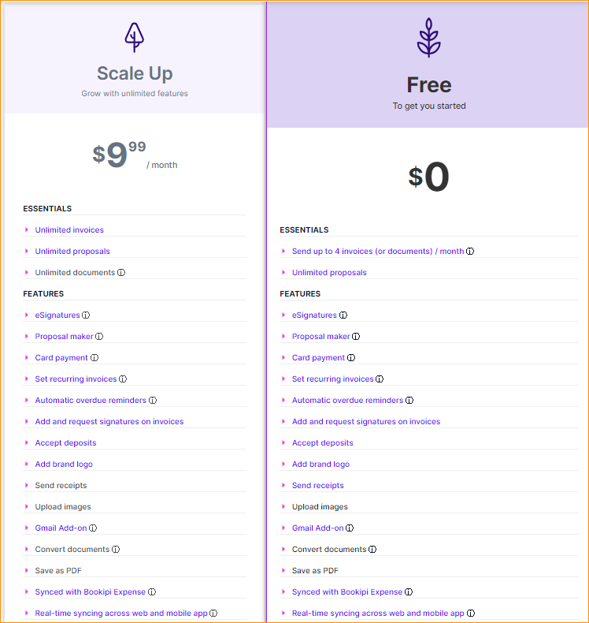

1. Web wave

<https://webwave.me/ai-website-builder?forcePageWithoutCdn=true>

